This Hands-On Practice is derived from the course lecture presentation (File Name: “*Users_Groups_Permission”). Please review the content of the document, it will help you to do this assignment.

**Task #1: Edit your .bashrc**

* *Exercise:* Create an alias of cd to your Window OS Desktop directory.

e.g. alias cdt='cd /mnt/c/Users/john_/Desktop'

Capture your screen shot of cd from you Linux home directory to your PC desktop directory using the alias command. E.g.

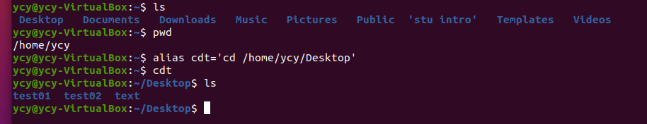

* *Exercise*: Make it so that whenever you try to delete or overwrite a file during a move/copy command, you will be prompted for confirmation first.

Suggestions:

* move/copy commands in Linux: mv/cp
* “man mv” and “man cp” for built-in help.
* Google/Baidu search for help on the command usage details (e.g. search terms: “how to prompt for overwrite in the cp command of Linux”).
* This link may help: <https://www.computerhope.com/unix/ucp.htm#:~:text=To%20view%20output%20when%20files,%2Di%20(interactive)%20option>.
* cp -i … may help

Capture your screen shot of mv/cp command execution (be sure to have prompt for overwrite) below.

Mv

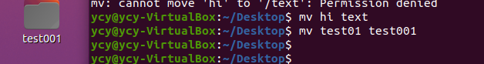

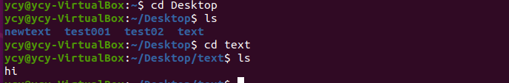

cp

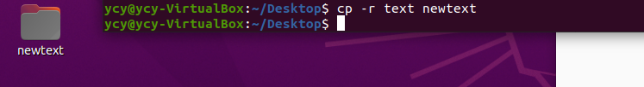

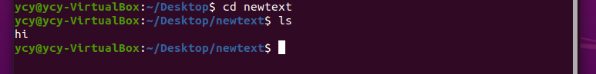

**Task #2: Change file permissions on a file.**

* Change the permissions on “myfile.txt“, so that:
  + Others cannot read it.

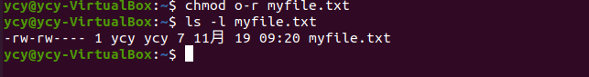

* + Group members can execute it.

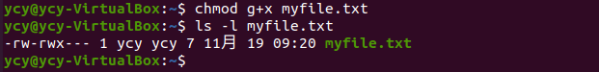

* + Others cannot read or write it.

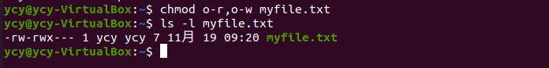

* + Group members & Others can read and write it.

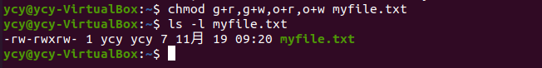

* + Everyone has full access.

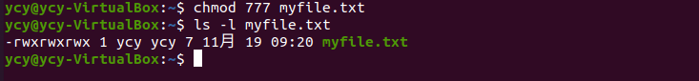

* Now try this:
  + Deny all access from everyone.

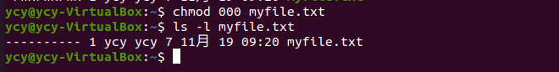

Suggestions:

* You can create “myfile.txt” file with your Hello World program codes (output re-direction).

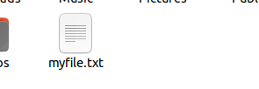

Capture your screen shot of your execution results (per “ls -l myfile.txt” command) below.

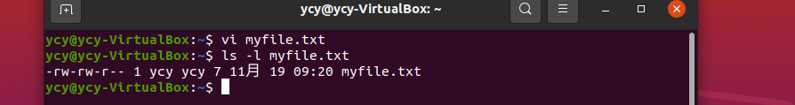

Lab Assignment Delivery Instructions:

* *Capture screen shots of your practice session results and paste* ***into this document accordingly****.*
* *Add/Replace the “demo” screen shots seen in this document with your results.*
* *Please elaborate as needed.*

**Submission:**

Please submit to online. If that fails, email your results to: bangpanliang@gmail.com.

The subject of the email should be: [Your StudentID, Assignment Name]